OutSystems courses completed 2026
https://learn.outsystems.com/training/journeys/agentic-development-4317/what-is-agentic-development-/odc/14263
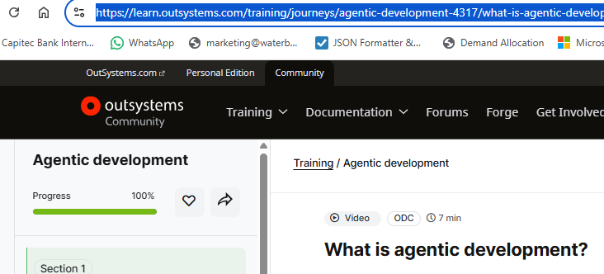

https://learn.outsystems.com/training/journeys/build-agentic-powered-app-3411/the-business-case-for-agentic-ai/odc/10811
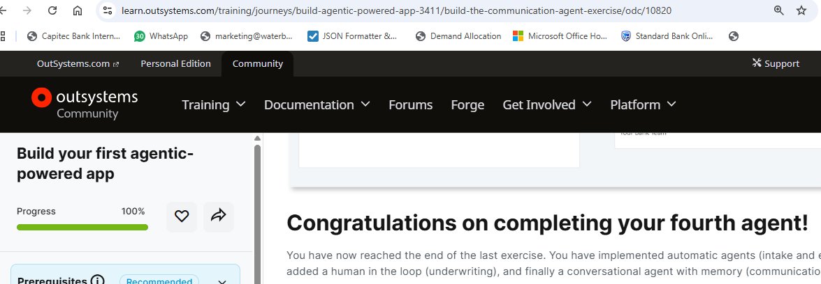

https://learn.outsystems.com/training/journeys/consuming-rest-api-207/quiz/odc/2971
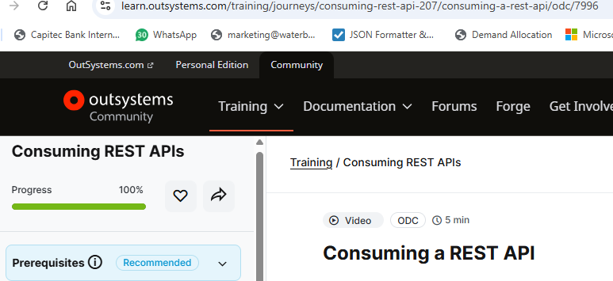
https://learn.outsystems.com/training/journeys/mobile-plugins-678/mobile-plugins/odc/665
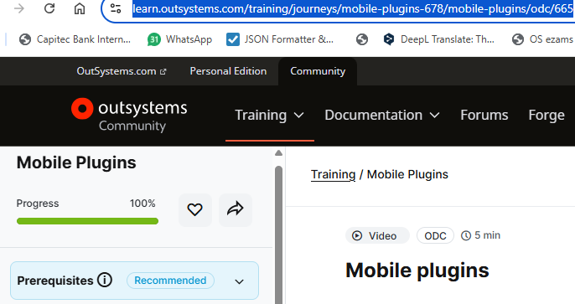

https://learn.outsystems.com/training/journeys/from-o11-to-odc-569/scenario-overview/odc/239
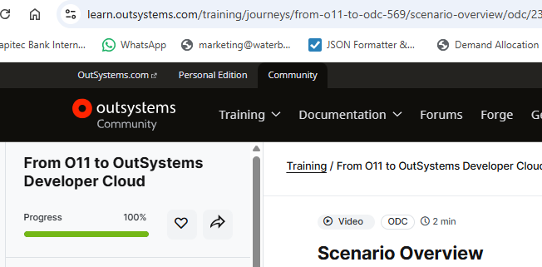

https://learn.outsystems.com/training/journeys/intro-to-outsystems-development-570/quiz/odc/47
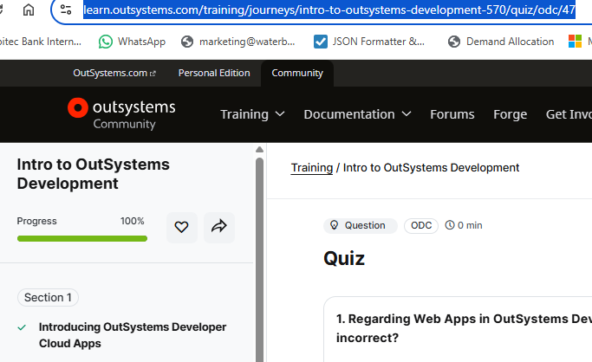

https://learn.outsystems.com/training/journeys/role-based-security-575/role-based-security/odc/507
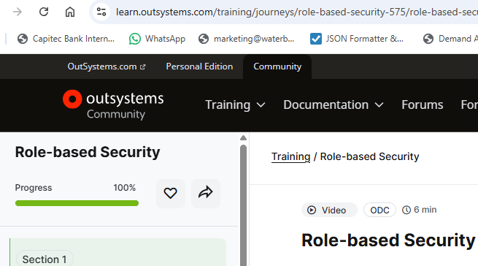

https://learn.outsystems.com/training/journeys/settings-370/settings/odc/177
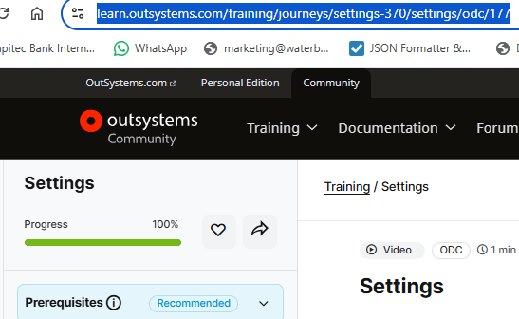

https://learn.outsystems.com/training/journeys/mobile-design-considerations-463/designing-mobile-apps/odc/3775
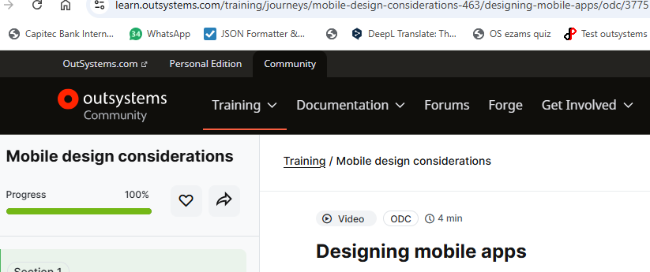

https://learn.outsystems.com/training/journeys/web-developer-662/getting-started-with-odc-overview/odc/523
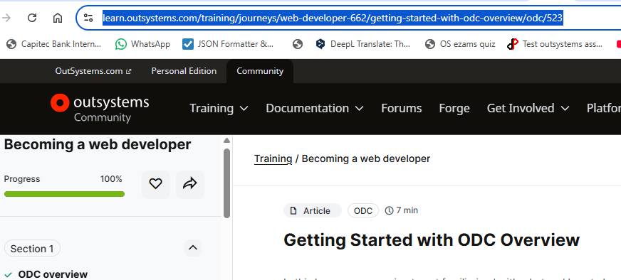
2026-10-16

